**Market Segmentation and Sizing**

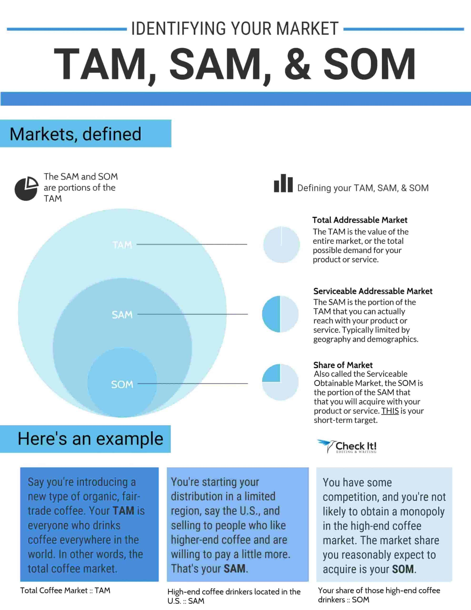

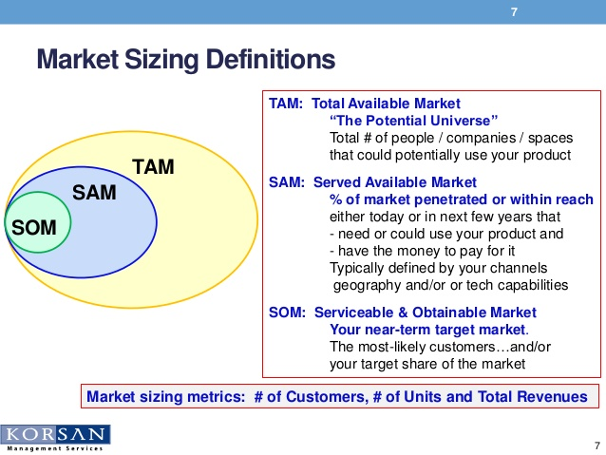

* For another tutorial on market sizing, watch these videos: <https://www.youtube.com/watch?v=vVfQnaIAKNc>

<https://www.youtube.com/watch?v=TM3PYBcrCgM>

* Also see additional details on market sizing in the following presentation

<https://drive.google.com/file/d/1HYjs6u-zSNBqcCDbe70HOZI-LO3I_pJQ/view?usp=sharing>

* Conduct Google searches with carefully selected search terms or questions
* For a deeper dive, contact your business librarian and tap into your library resources for market research.

**What is the target market and potential size for your idea(s)?**

|  |  |  |
| --- | --- | --- |
| Market Guestimation Worksheet | Description by type and geography | Guestimate of # of customers and/or $ spent per year in this segment |
| TAM |  |  |
| SAM |  |  |
| SOM/Target |  |  |
| Beachhead  (The small group of early adopters who are hungry for change, less risk averse, and likely to want your product even though it is not yet perfected.) |  |  |